Quail and Pheasants
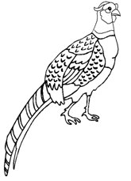

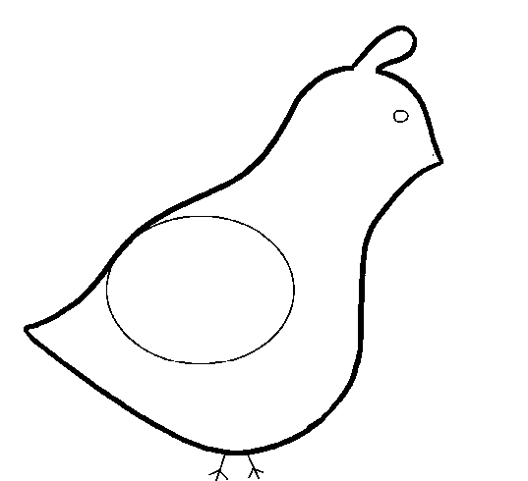

Which one is the Pheasant?

We raise Quail and Pheasants for fun. They are small and are migratory. Migratory means they move from place to place. We have Northern Bob White Quail.
Ring-necked Pheasant are native to Asia but have been released throughout the world, as they are good game birds. Females lay a clutch of 12 brown eggs each year. Male Pheasants have long colorful tails and a red ring around their neck. Female Pheasants are brown-colored.

